Sunbeam Institute of Information Technology
Preparatory Assignments

C Programming Assignments

Q1. Write a program to input n numbers on command line argument and calculate maximum of them.
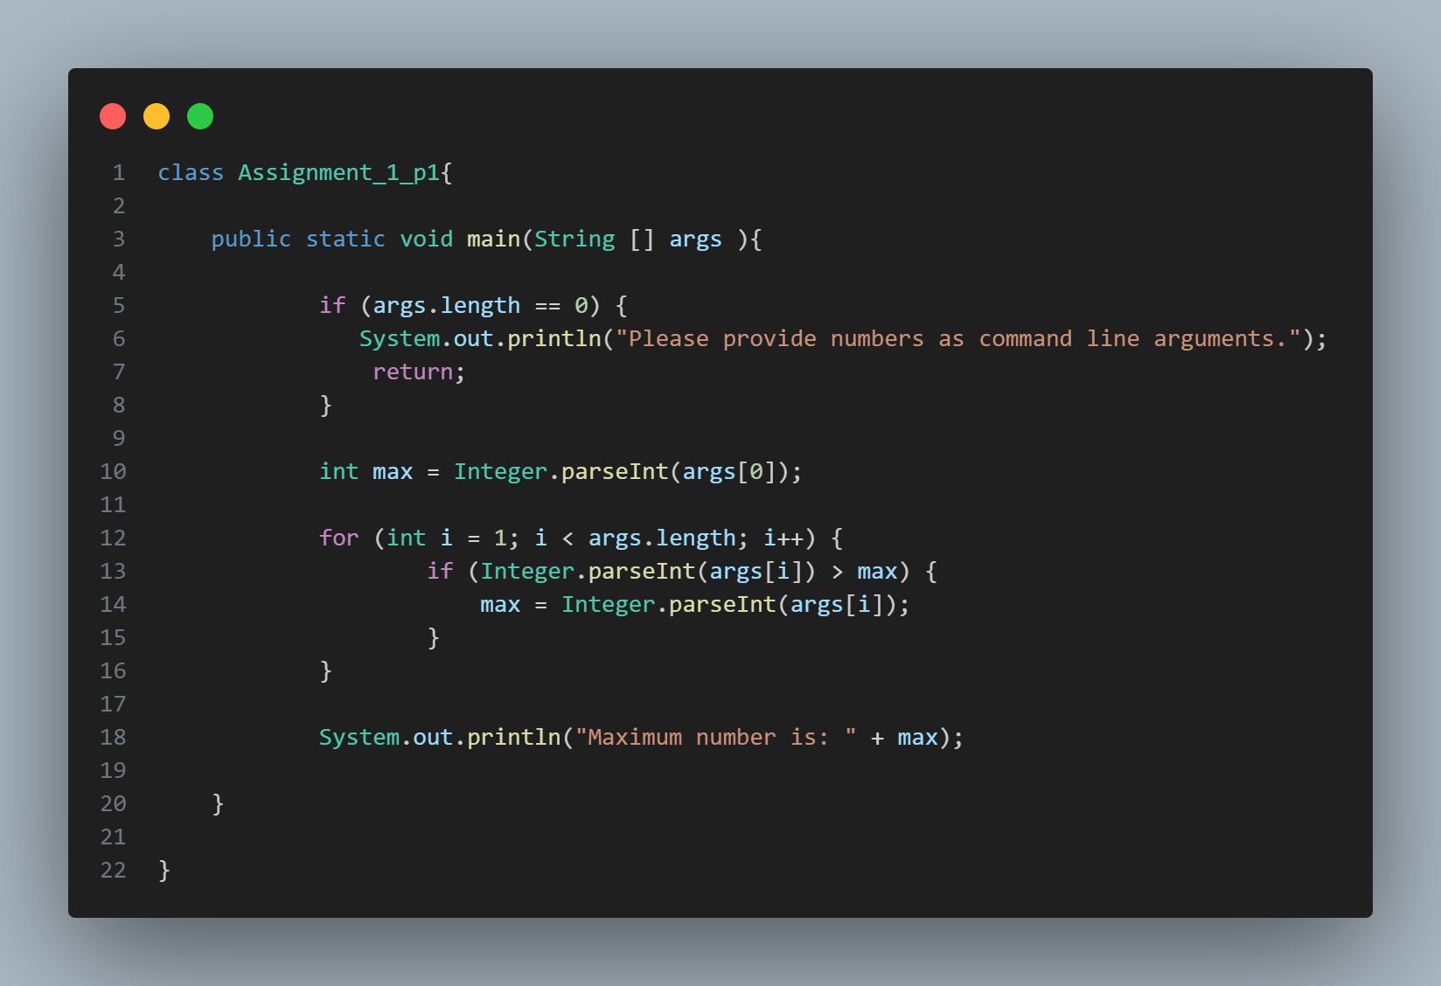

Q2. Write a program to calculate a Factorial of a number.
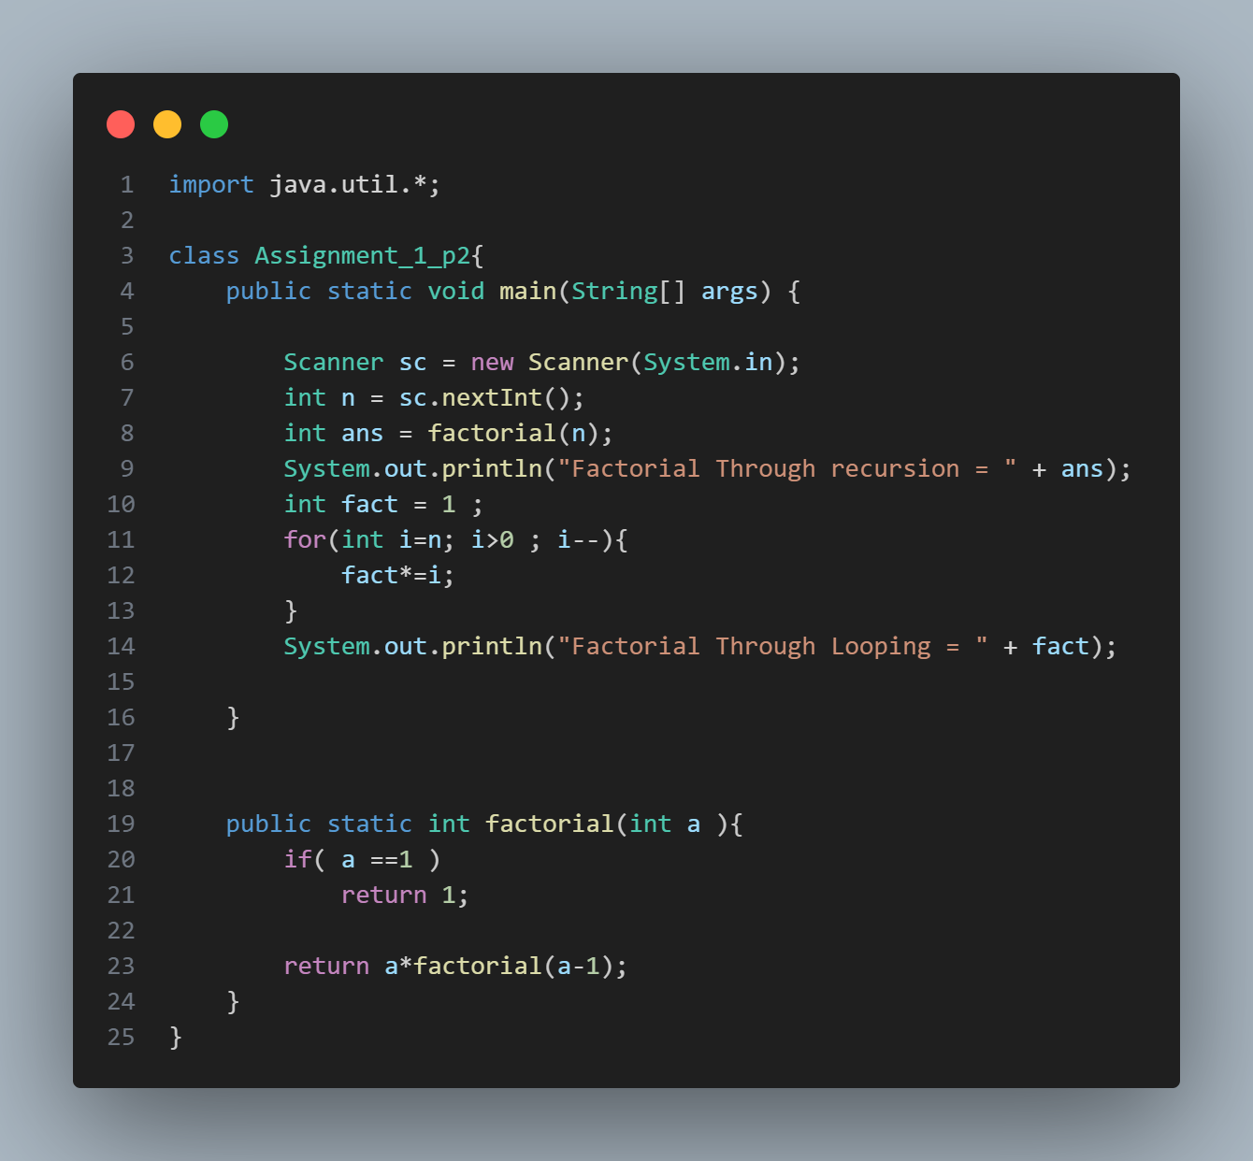

Q3. Write a program to calculate Fibonacci Series up to n numbers
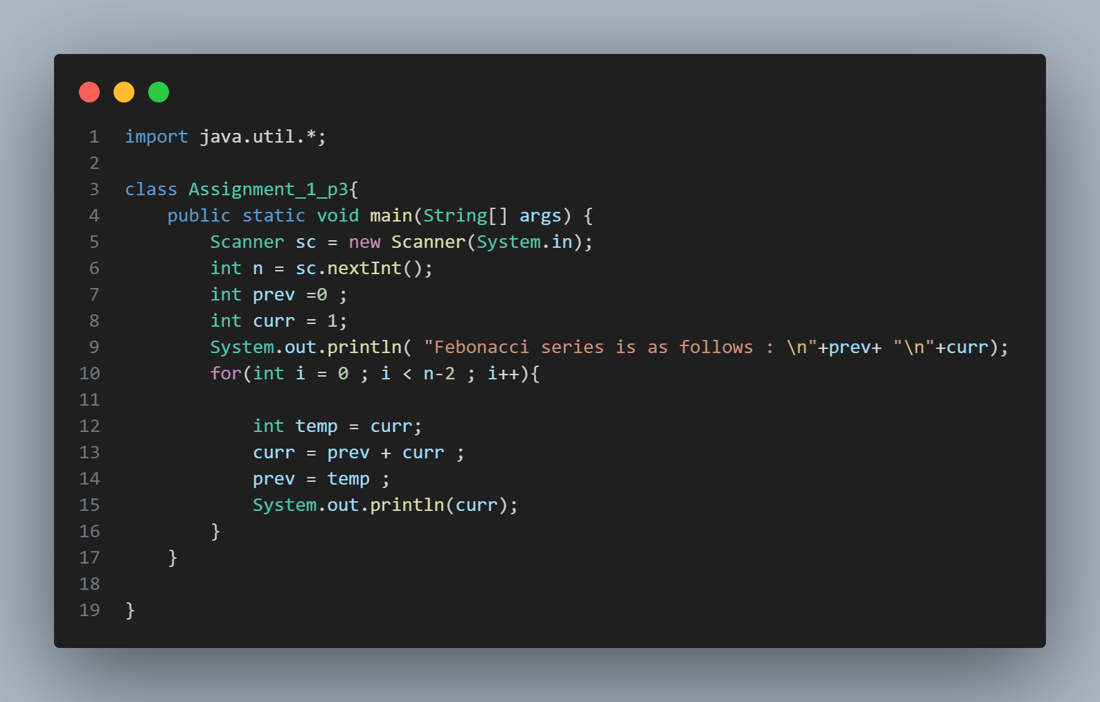

Q4. Write a program to calculate the grade of a student. There are five subjects. Marks in each subject are entered from keyboard. Assign grade based on the following rule:
Total Marks >= 90 Grade: Ex
90 > Total Marks >= 80 Grade: A
80 > Total Marks >= 70 Grade: B
70 > Total Marks >= 60 Grade: C
60 > Total Marks Grade: F

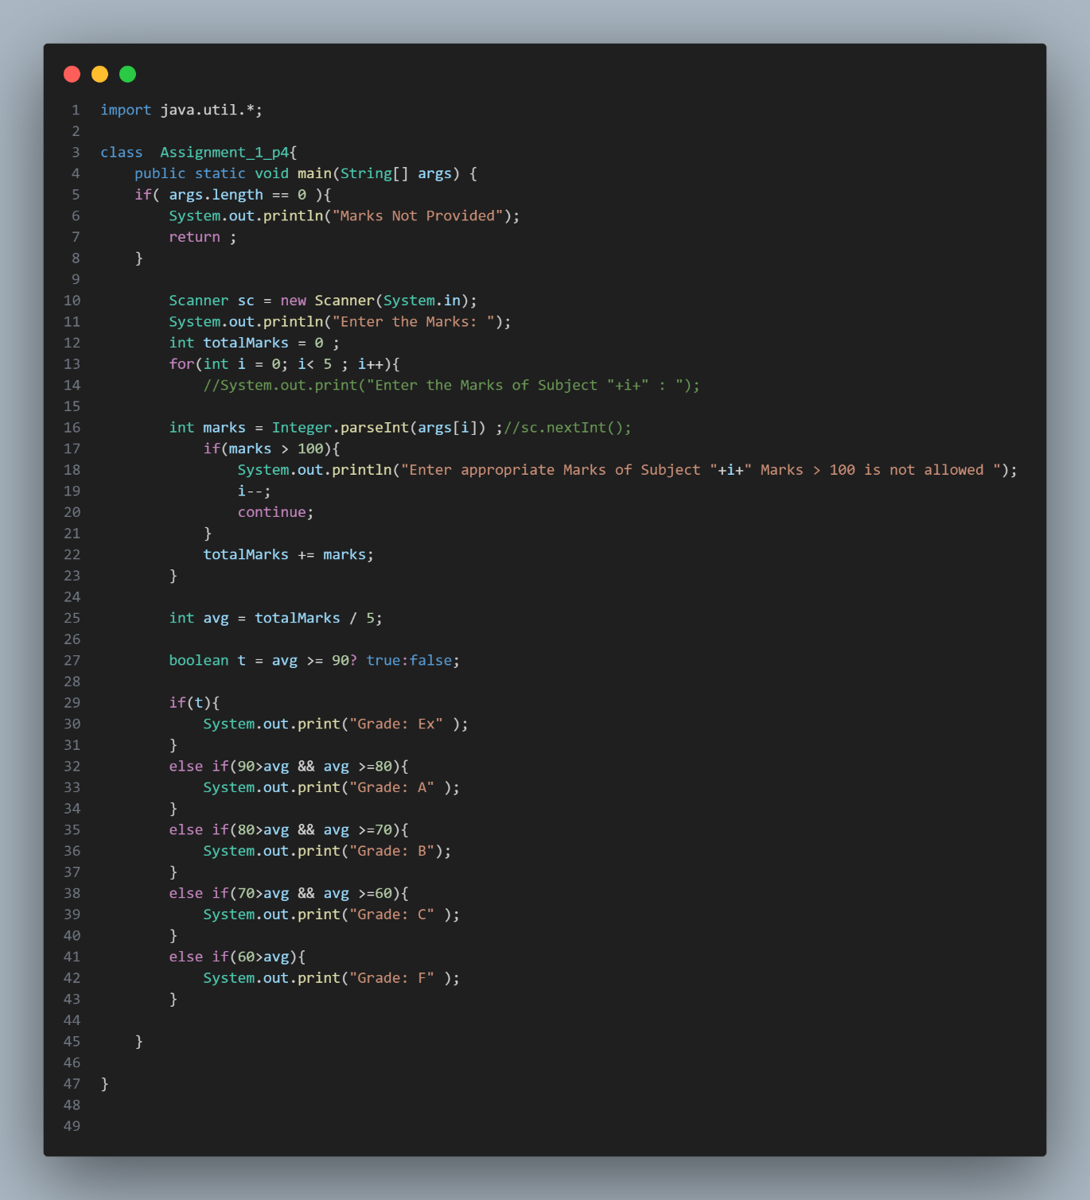
Q5. Write a program to check the input characters for uppercase, lowercase, number of digits and other characters. Display appropriate
message.
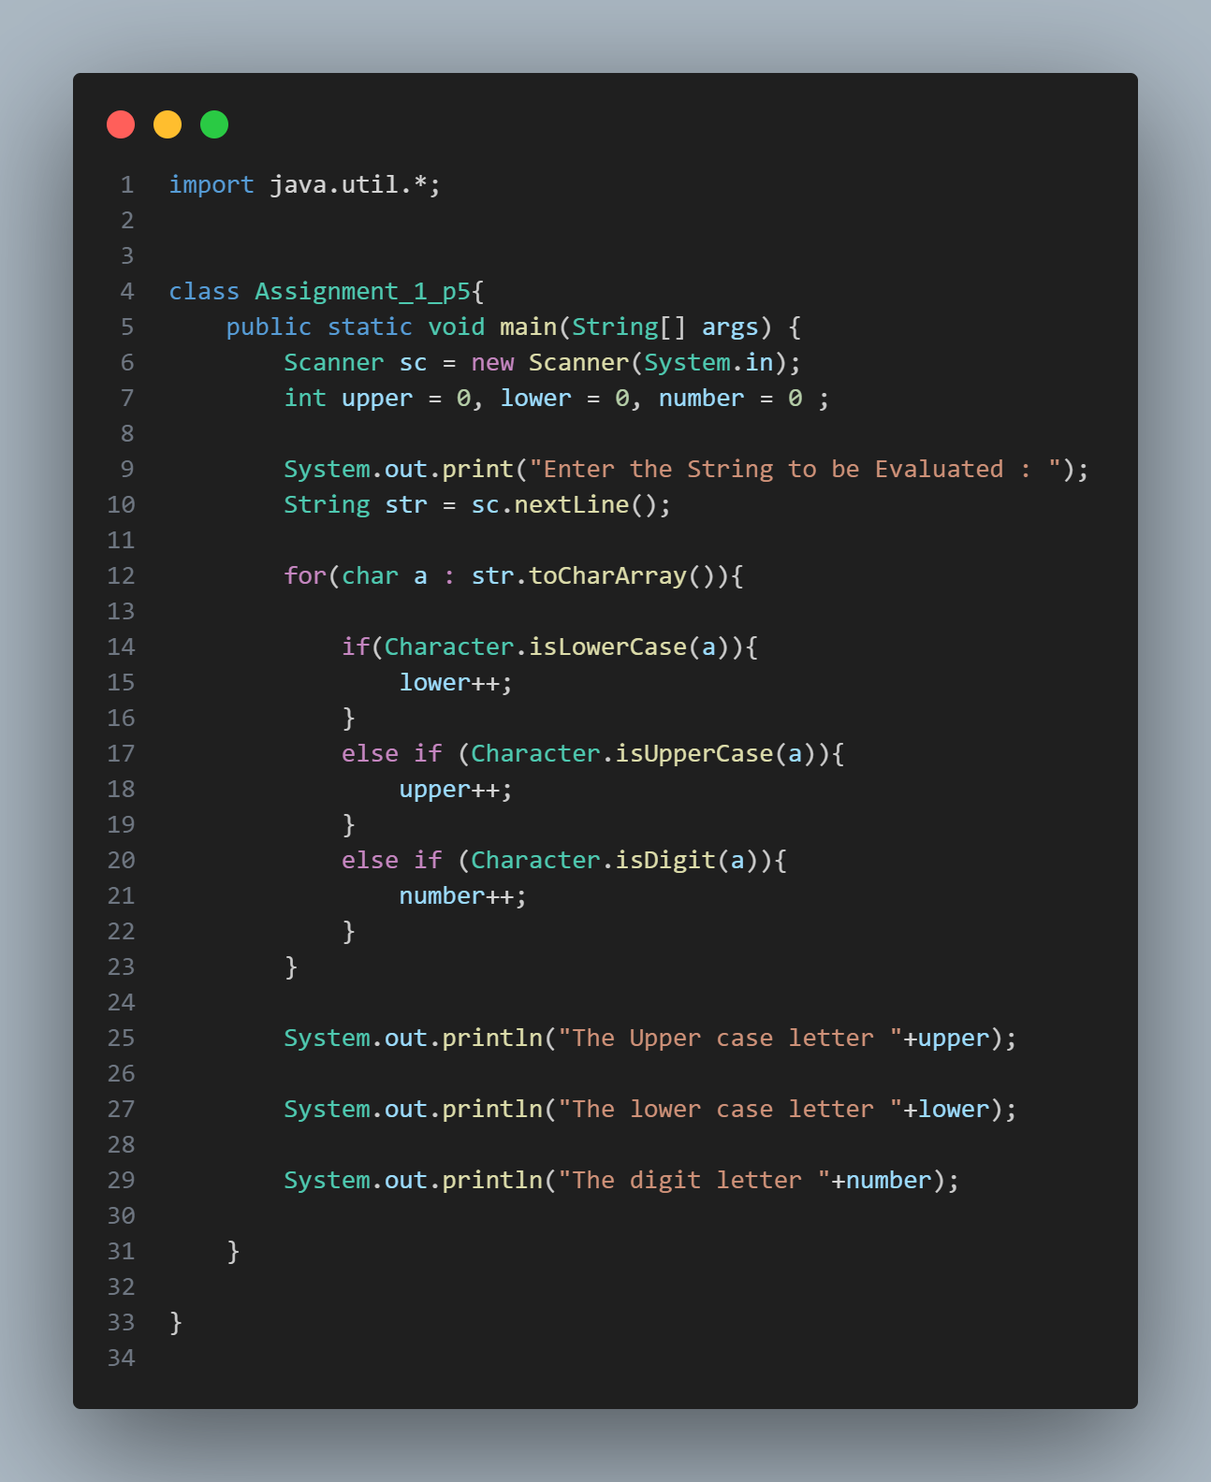

Q6. Write a program to perform matrix multiplication.
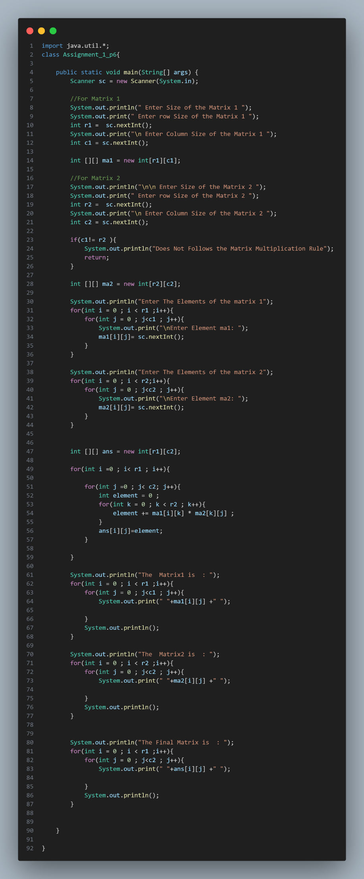
Q7. Write a java program to accept a number from user using command line argument and display its table.
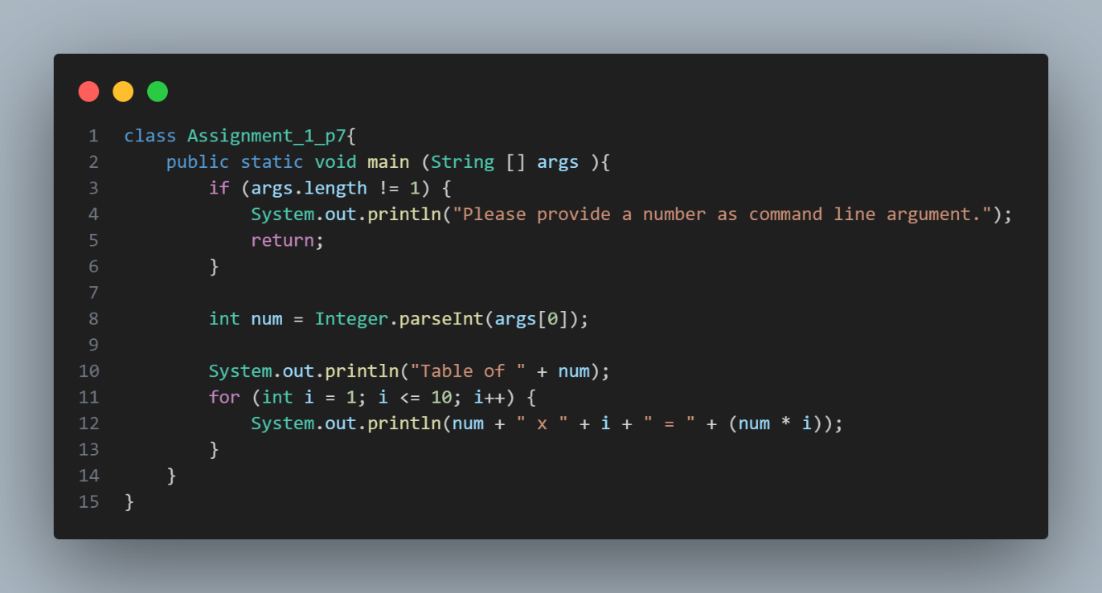

Q8. Write a program to read the name of a student (studentName), roll Number (rollNo) and marks (totalMarks) obtained. rollNo may be an alphanumeric string. Display the data as read. Hint: Create a Student structure and write appropriate functions.
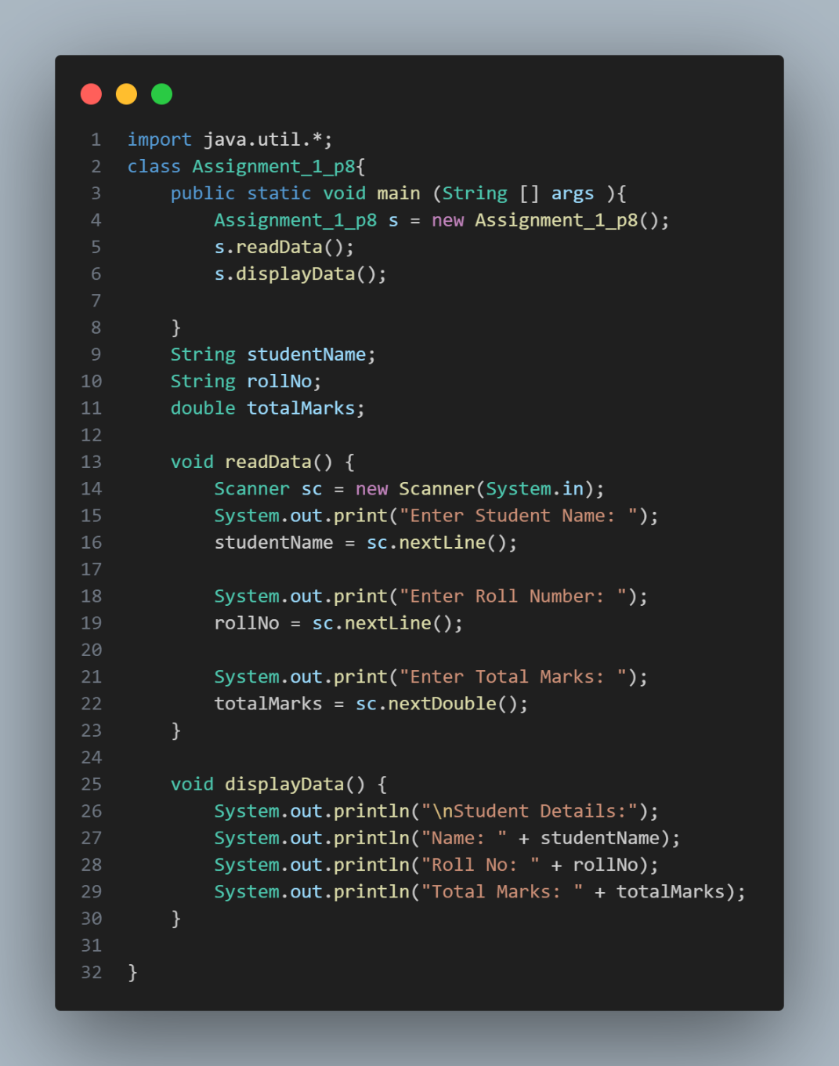
Q9. Accept an integer number and when the program is executed print the binary, octal and hexadecimal equivalent of the given number.
Sample Output: terminal> java Test Enter Number : 20
Given Number :20
Binary equivalent :10100
Octal equivalent :24
Hexadecimal equivalent :14
Hint: Use bitwise operators for binary conversion. Octal/Hexadecimal conversion to be done by repetitive division using recursion.
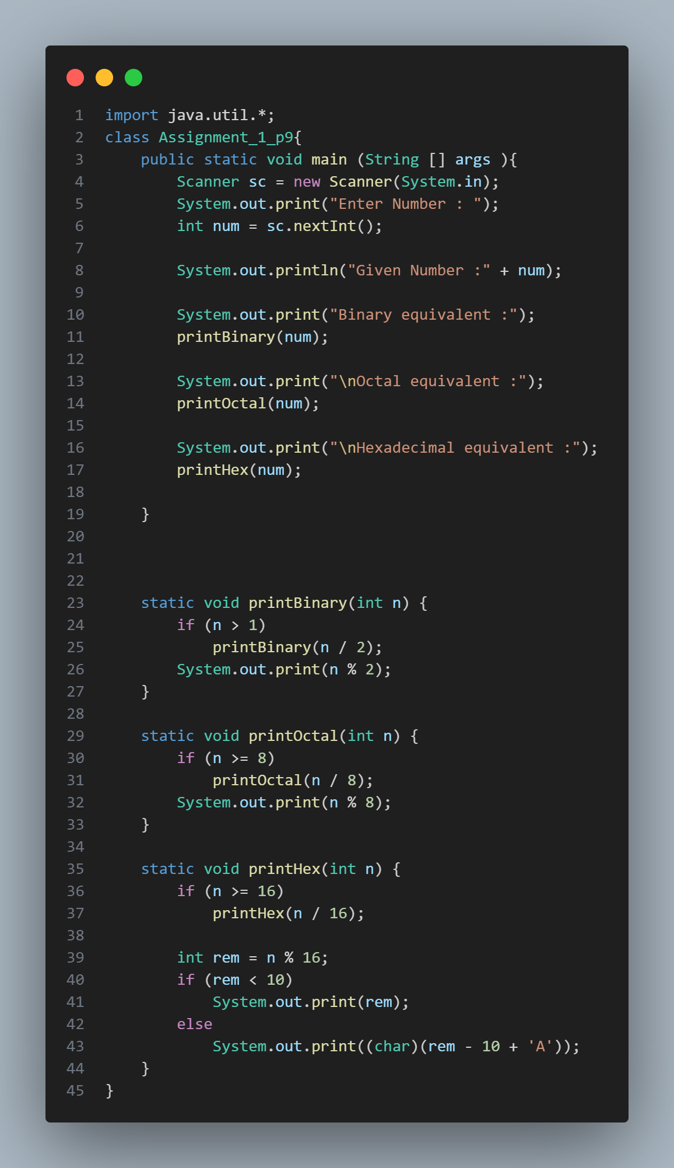
Q10. Read at most 10 names of students and store them into an array of char nameOfStudents[10][50]. Sort the array and display them back. Hint: Use qsort() method.
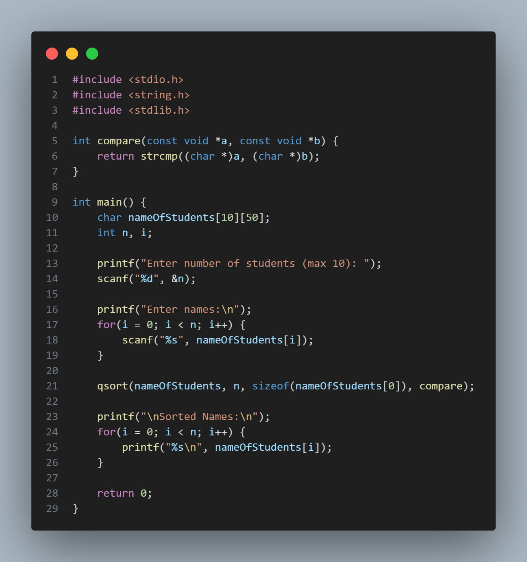

Q11. Create a structure called Employee that includes three fields - a first name (type String), a last name (type String) and a monthly salary (double). Write functions to initialize the fields, print them and modify the values in the given object. Example methods:
- void emp_init(struct emp* e);
- void set_salary(struct emp *e, double sal);
- void emp_display(struct emp *e);
Write the test code in the main(). Create two emp objects and display each object’s yearly salary. Then give each Employee a 10% raise and display each Employee’s yearly salary again.
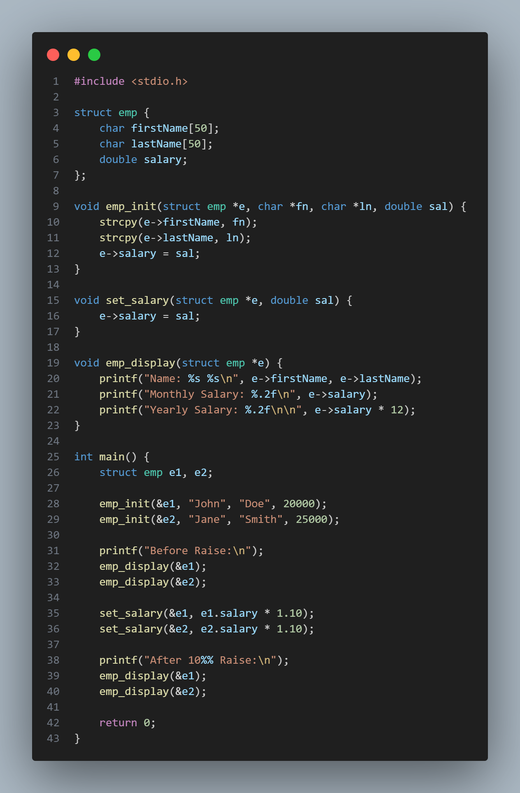
Q12. Write a Program to reverse the letters present in the given String. Do not use strrev() function.
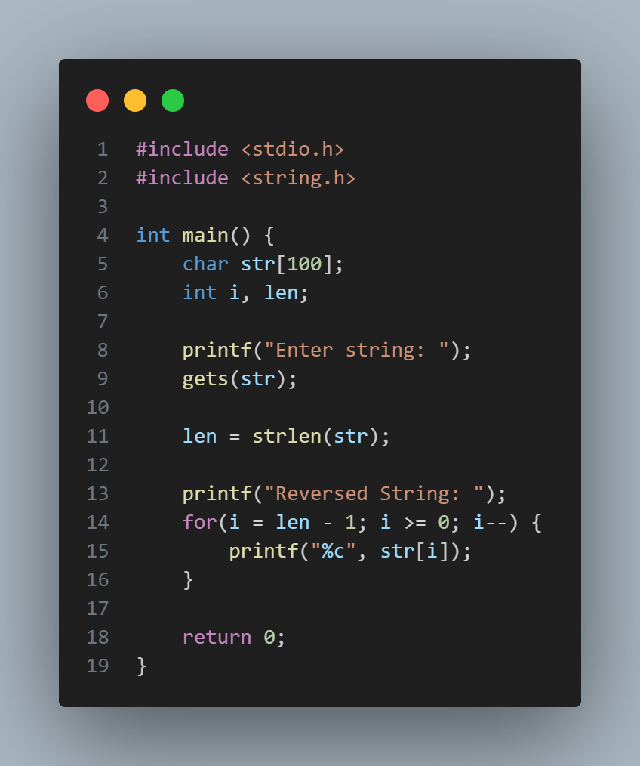

Q13. Declare an Array of type char* and initialize it with a few strings (hardcoded). Display the strings which are duplicated in that array. (Hint: use strcmp())
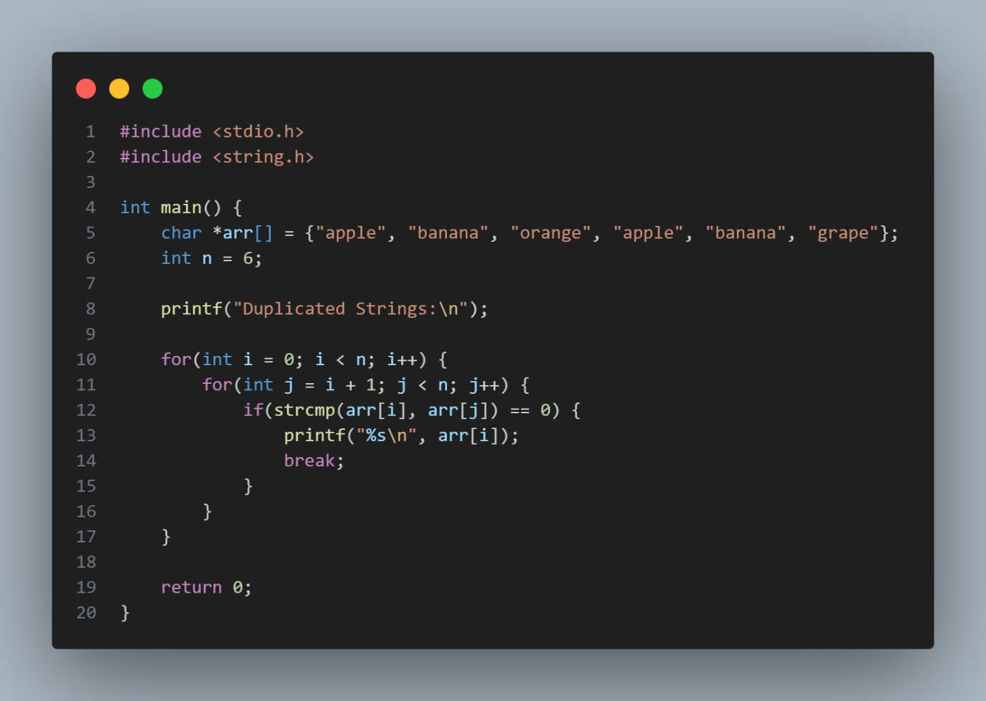

Q14 Write a java code to check if string is palindrome.
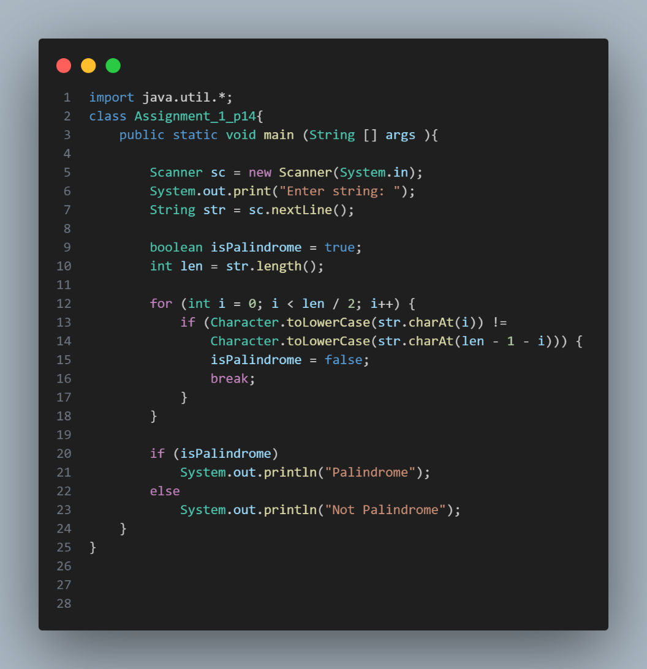
Q15. Input a string from the user. Count occurrences (case insensitive) of each alphabet in the string.
Sample output:
Input: Welcome to SunBeam.
Output:
- : 1
- : 1
- : 1
E : 3
- : 1
- : 2
- : 1
- : 2
- : 1
- : 1
- : 1
W : 1
